Question 4

**i)** Find all customer accounts whose balance is smaller than **R700.**

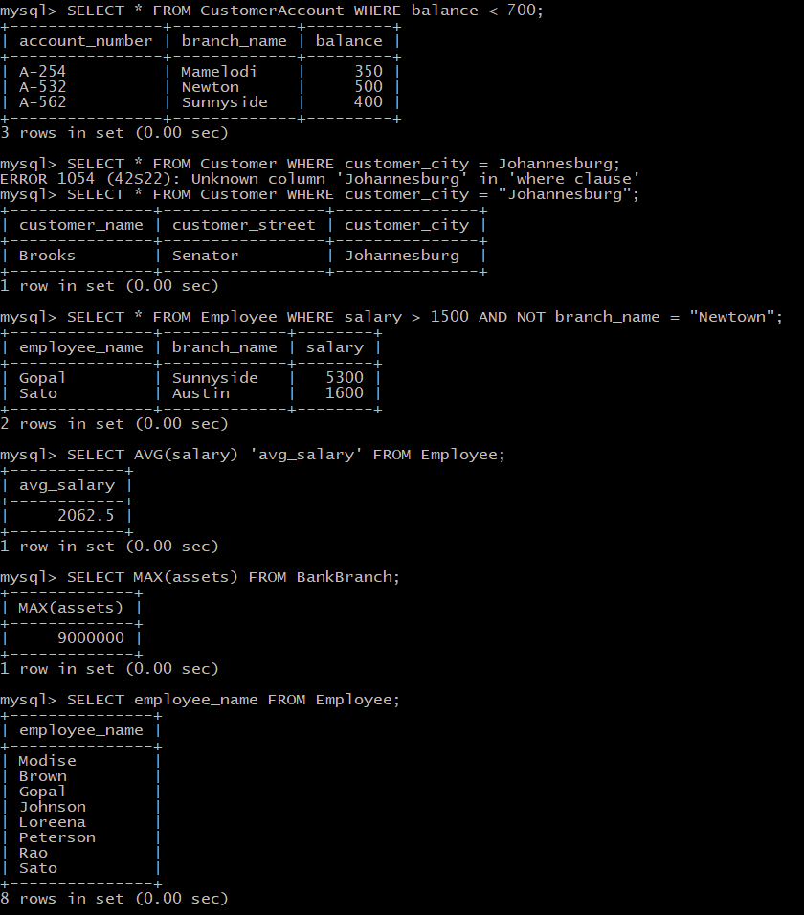

**ii)** Find all name of customers whose city is in **Johannesburg.**

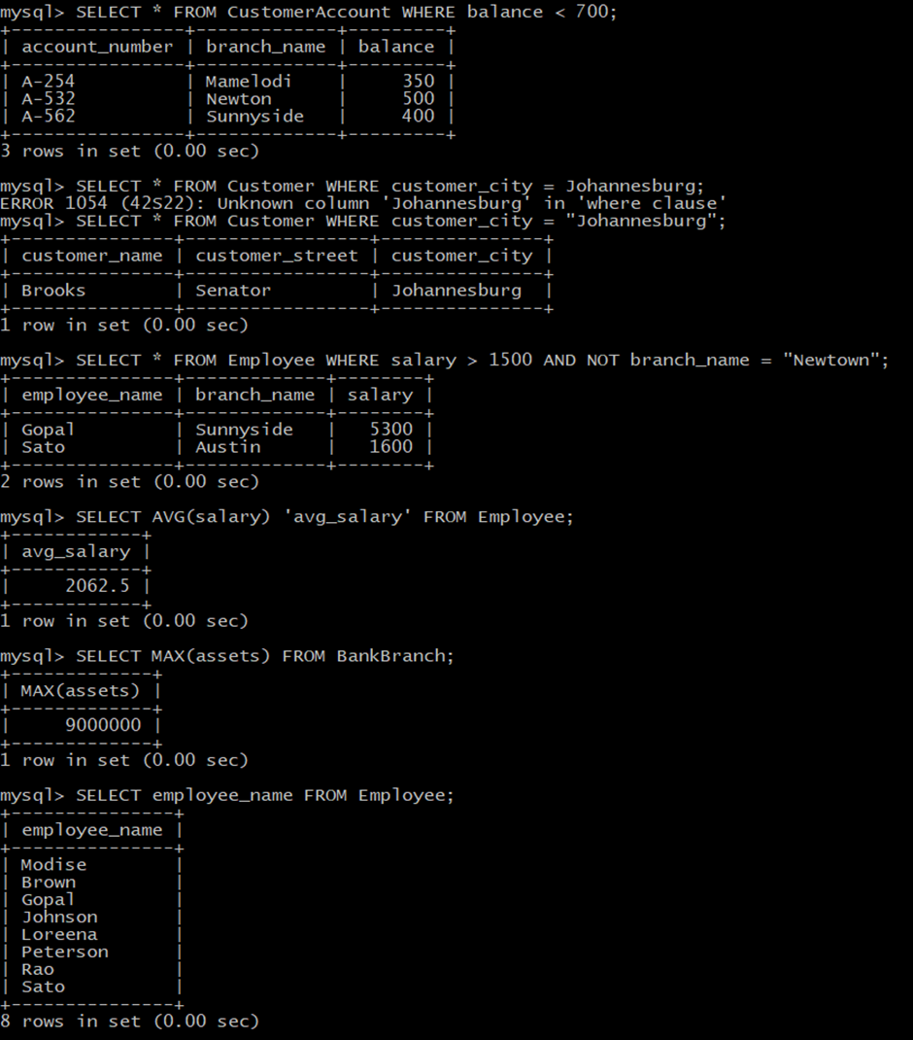

iii) Find all employees whose salary is greater than **R1500** and working branch is not

**Newtown.**



iv) Calculate the average salary of all employees and show the average salary as

**“avg_salary”**



v) Display the bank with the largest number of **Assets**.



Question 5

i) Display the names of all employees who work in **Sunnyside** branch.

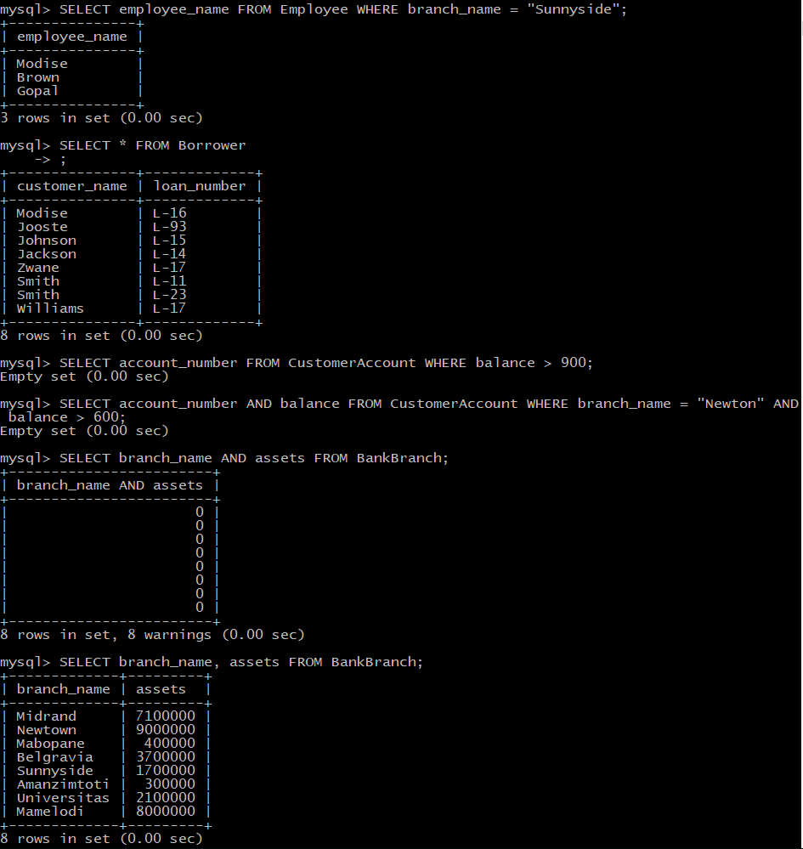

ii) Display the **borrower** table.



iii) Find the account number for all accounts where the balance is greater than

**R900.**



iv) Find the account number and balance for all accounts from **Newtown** where the balance is greater than **R600**.



v) Display the branch name and assets from all branches.

